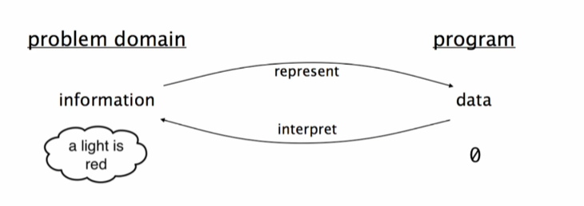

Problem domain – real-life interpretation of problems

On the example, there are no direct interpretation of data

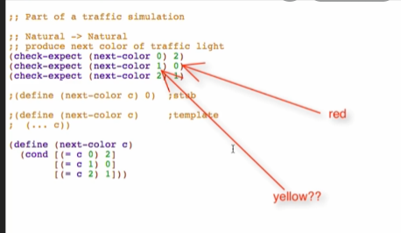

This is where data definition will be placed in

Sample of the program with data definition:

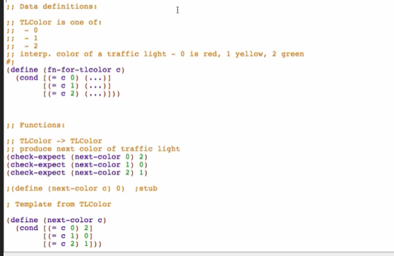

Type-comment

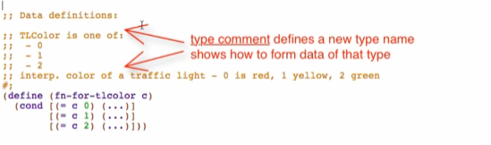

Interpretation

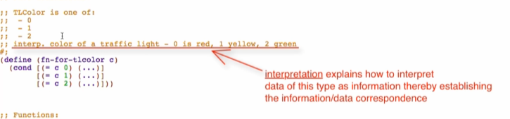

Template for operating on the data

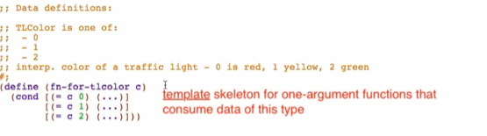

We can now be more specific with our function definition! 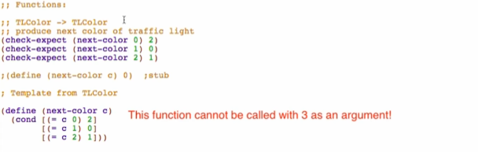

Data Definitions

* Describe:
  + How to form data of a new type
  + How to represent information as data
  + How to interpret data as information
  + Template for operating on data
* Simplifies function
  + Restricts data consumed
  + Restricts data produced
  + Helps generate examples
  + Provides template